# Multi-Tenant Architecture Comparison

MTA = Multi-Tenant Architecture patterns

Goal: Choosing an applicable multi-tenant architecture

Multi-tenant Layers

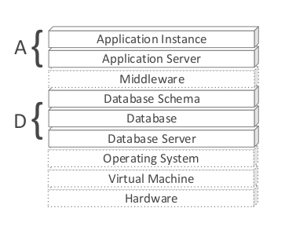

Notice Multi-tenant at **Application Level** and **Data Level**

### Application related layer set:

The different levels result from identifying ascending levels of sharing among all layers on the set:

1. AD - A Dedicated Application **server is running for each tenant,** and therefore each tenant receives a dedicated application instance.
2. AS - A single Application **Server is running for multiple tenants** and **each tenant receives a dedicated application instance.**
3. AI - A single application server is running for multiple tenants and a **single Application Instance is running for multiple tenants.**

### Data related layer set has these tenancy levels:

1. DD - A Dedicated **Database server is running for each tenant**, and therefore each tenant receives a dedicated database.
2. DS - A single Database Server is running for multiple tenants and e**ach tenant receives a dedicated database.**
3. DB - A single DataBase server is running for multiple tenants, data from multiple tenants is stored in a **single database,** but **each tenant receives a dedicated set of tables**.
4. DC - A single database server is running for multiple tenants, **data from multiple tenants is stored in a single database and a single set of tables**, **sharing** the same Database **sChema**.

### The number of possible architectures is twelve

M T A = ( {AD, AS, AI} , {DD, DS, DB, DC}

MTA Comparison Matrix

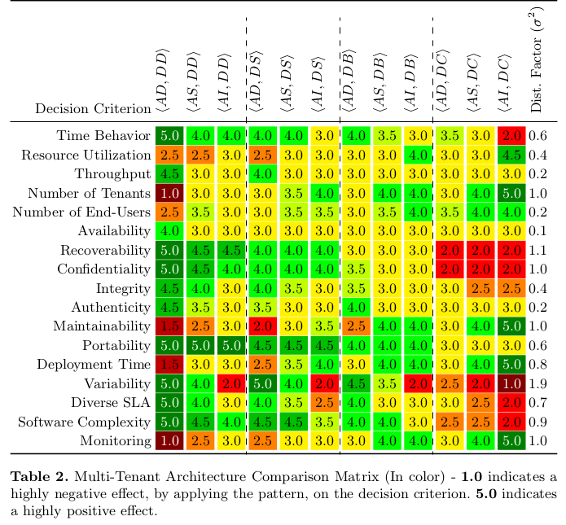

Notes:

* Focus on the database dimension
* Sharing database tables enables serving of many tenants but harms robustness
* Sharing application instances helps maintainability and performance but harms variability
* Ease of implementing variability differs greatly per MTA
* Dedicated servers improve performance and variability, but hamper scalability

What is Wrong? These numbers are taken from 10 domain experts,The small sample of 10 domain experts used may lead to biased results.

(paper at: <https://pdfs.semanticscholar.org/17fb/e778244aa190da9d56c5fb8c2e64c63cd621.pdf>)

*الجميل* هو تعداد الsoftware architecture الموجودة و جمع الاحتمالات المختلفة لها مع بعضها البعض و يمكن ملاحظة أن ما سنختاره من بنية يجب أن يتوسط من حيث المعايير المختلفة الموجودة على يسار الصورة

انا افضل اختيار: (DB,AI) او (DB,AS) أي بالحالتين لكل شخص مجموعة من الجداول خاصة به ولكن الmulti-tenacny على مستوى التطبيق اما AI(التطبيق نفسه يخدم اكتر من شخص) او AS( اعطاء لكل شخص نسخة من التطبيق)

*السيء* أن الأرقام في اخر صورة مأخوذة من 10 خبراء فقط ممّا يدل على نقص في الدراسة ولو كانت جيدة بالمجمل